2019
  - Annual General Meeting
Victim Services Hastings, Prince Edward, Lennox and Addington  Please R.SV.P. to Jennifer Cormier By September 23th, 2019  613.771.1767  or  victimservicesed@bellnet.ca | 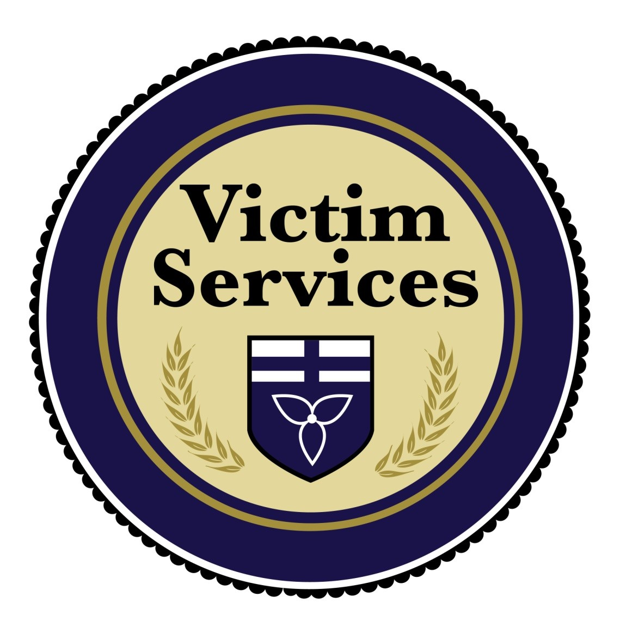

Monday September 23, 2019
5pm – 7pm
250 Sidney St. Belleville, ON
Theatre Room

Complimentary Food and Beverages will be served

